NAME:_________________________
Hour:_______
Space Science Test Review
This study guide will be used for the final test of the semester as well as a major portion of the midterm. To earn full credit you must write in complete sentences and answer all questions as thoroughly as possible.
Vocabulary
- Zenith-
- Meridian-
- Horizon-
- Altitude-
- Astronomical Unit –
- Black Hole –
- Astronomy -
- Light Year -
- Terrestrial Planets –
- Constellation –
- Waning –
- Waxing –
- Revolution –
- Rotation –

Fill in the Blank
- Stars are balls of _____, mostly ___________, that produce light by nuclear reactions in their cores.
- In a nuclear fusion reaction, ________ nuclei combine to form a _____________ nuclei.
- Interstellar space is composed of mainly ____.
- One _____________ ________ is the average distance between the Sun and Earth.
- Stars can only be studied by the _______________ they emit.
- The ___________________ of a star is indicated by the color it glows.
- The apparent brightness of stars depends on two things: ________________ and ________________.
- Our sun will eventually become a ____.
- The moon ___________ light from the sun onto the earth’s surface.
- The smaller the magnitude number, the ______________ the star.
- A light-year is a unit of _______.
- Stars form in a ______________.
- As a star increases in absolute magnitude, it appears _______ on Earth
- Stars __________ light. Planets _________ light.
- The average distance between Earth and the Sun is called a(n) ____.
- As particles move closer together, _______________ increases.
- The process by which hydrogen is changed to helium in the core of a star is called ______.
- We live in the ____________ ___________ galaxy
- A star that is blue in color is ____ than a star red in color.
- The Milky way galaxy is this type of galaxy __________________
- Saturn's rings are made up mostly of ______________________________________

Short Answer (remember in complete sentences as well as thorough)
- Why is it that the moon changes in appearance over time? I would like for you to explain this in your own words. You can use any visuals or any knowledge we have discussed in class.

- In your own words explain to me what a/n
Meteorite is:

Asteroid is:

Comet is:

- Explain to me he we know what stars are made of and how we know how hot they are?

- Why do we experience seasons?

- What stars have a longer life, large Stars or small stars and why?

- How long is the lunar cycle? Or for that matter what is the lunar cycle?

- Describe a waning Gibbous

- What is a lunar eclipse, and how does it happen (include a drawing)?

- What is a solar eclipse, and how does it happen(include a drawing)?

- List the different classifications/types of galaxies.

- What is a black hole and how do we think they are formed?

- What is the force that keeps out planets in their orbits? ( you should be able to at least list 2)

- What is a big difference in the composition (what the planets are made of) from the outer planets to the inner planets? Explain both compositions.

- Why does the same side of the moon always face the Earth?

- What is it called when you can see a constellation year round?

- Why can we only see some constellations during specific times of the year?

Label the following picture and shade it in with the terms and drawings below. 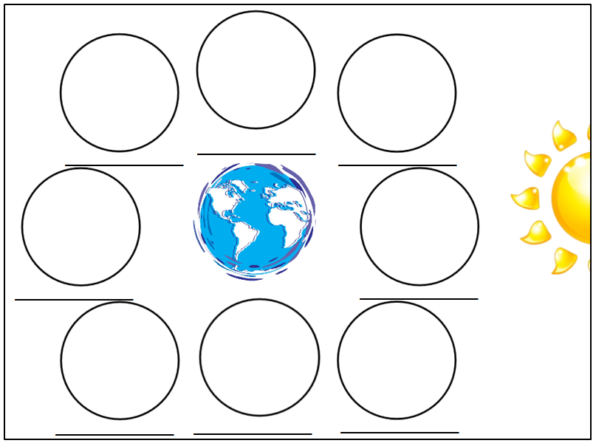
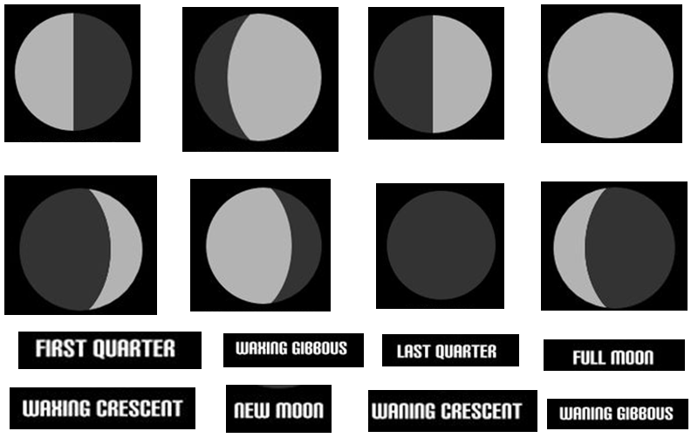

On the following blank spectra read out, fill in the given elements.

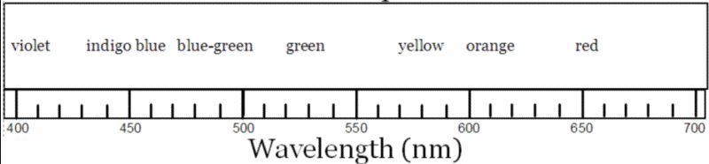
Gold: 451,455 to 462, 656

Aluminum: 444, 510, 555, 679

Einsteinium: 411 to 417, 456 to 467, 556 to 567, 690

Explain to me the life cycle of a small star and a medium star. From birth to death.

Small star life cycle-

Large star lifecycle –

List the 8 planets we have in our solar system starting with the one closest to the sun.

